**ALPSKE POKRAJINE**

**(Bohinj, Vrba)**

**TERENSKI DNEVNIK**

7. razred, šolsko leto 2016/17

(Vsebine: opazovanje poti, ledeniško preoblikovano površje, podnebje, rastlinstvo, gospodarske dejavnosti)

Ime in priimek:______________ Razred:____________________ Datum: ________________

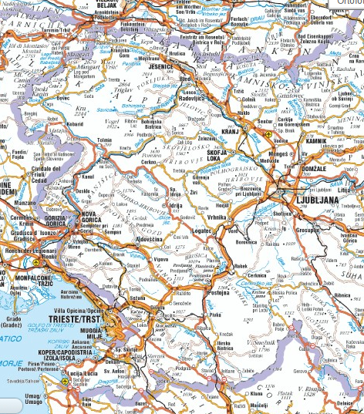

**1 SPREMLJANJE POTI**

a) Na zemljevidu označi opravljeno pot in mesta, kjer smo se ustavili. Oblikuj legendo.

b) Na poti opazuj pokrajino. Katere spremembe opaziš? Zapiši nekaj svojih ugotovitev.

_____________________________

_____________________________

_____________________________

_____________________________

_____________________________

_____________________________

_____________________________

_____________________________

_____________________________

_____________________________

_____________________________

Legenda

**2 BOHINJ (ledeniške oblike površja, rastlinski pasovi, značilnosti površja, TNP)**

**MOJE BELEŽKE:**

………………………………………………………………………………………………………………………………………………………………………………………………………………………………………………………………………………………………………………………………………………………………………………………………………………………………………………………………………………………………………………………………………………………………………………………………………………………………………………………………………………………………………………………………………………………………………………………………………………………………………………………………………………………………………………………………………………………………………………………………………………………………………………………………………………………………………………………………………………………………………..

…………………………………………………………………………………………………………………………………………………………………………………………………………………………………………………………..

…………………………………………………………………………………………………………………………………………………………………………………………………………………………………………………………………………………………………………………………………………………………………………………………………………………………………………………………………………………………………………………………………………………………………………………………………………………………………………………..

**3 VRBA (Prešernova rojstna hiša)**

**MOJE BELEŽKE:**

…………………………………………………………………………………………………………………………………………………………………………………………………………………………………………………………………………………………………………………………………………………………………………………………………………………………………………………………………………………………………………………………………………………………………………………………………………………………………………………..

…………………………………………………………………………………………………………………………………………………………………………………………………………………………………………………………………………………………………………………………………………………………………………………………………………………………………………………………………………………………………………………………………………………………………………………………………………………………………………………………………………………………………………………………………………………………………………………………………………………………………………………………………………………………………………….

…………………………………………………………………………………………………………………………………………………………………………………………………………………………………………………………